**Lesson 6 Demo 5**

**Adding Selenium Plugin to Jenkins**



Steps to be followed:

1. Adding Selenium Plugin to Jenkins



**Step 1: Adding Selenium Plugin to Jenkins**

1.1 Open the browser and go to Jenkins Dashboard (**localhost:8080**) and click on **Manage Jenkins** and then go to **Manage Plugins**.



1.2 Navigate to the **Available** tab. This offers a list of all available plugins.

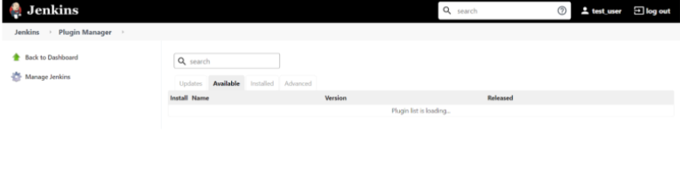

1.3 Now type **Selenium** for Selenium Plugin. Use the Filter bar on the right to find the tool that must be integrated.

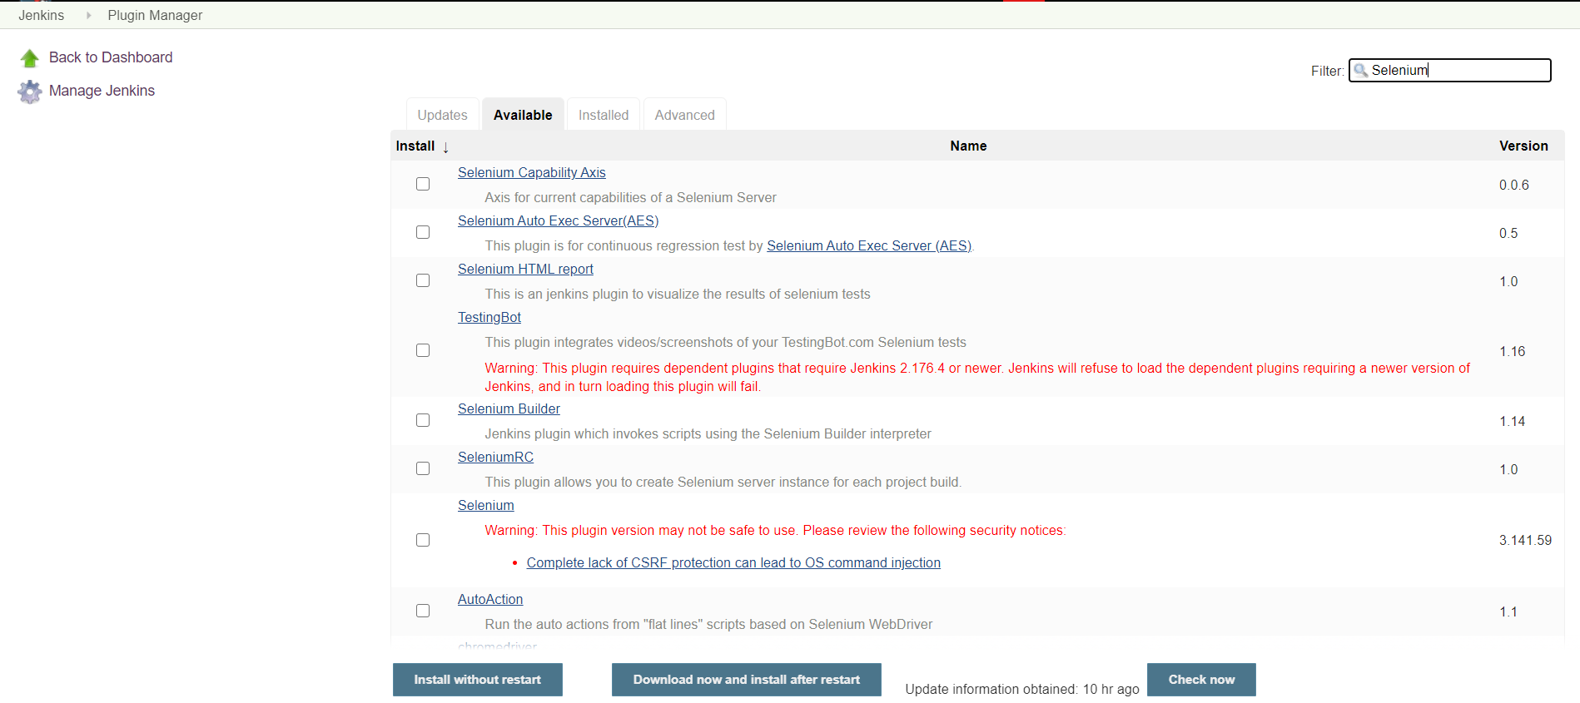

1.4 Select the plugin and click on **Install without restart**.